ZONTA YELLOW ROSE PINS
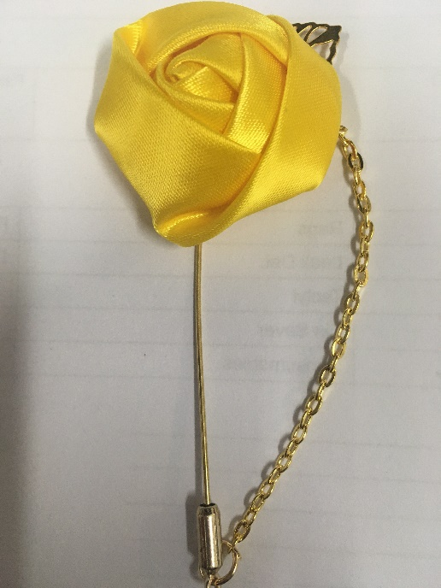

ZONTA CLUB OF  (Please omit if not being invoiced to your Zonta Club.) | DATE
CONTACT NAME | TELEPHONE
EMAIL
DELIVERY ADDRESS

Quantity | Description | Amount Due
 | Zonta Yellow Rose Pins @ $5 each | $
 | Postage | $ 8.95
 | TOTAL | $
For direct credit payments: Account Name: Zonta Club of Mackay Inc Bank: Bendigo Bank BSB: 633108 Acc Number: 150357358
Reference: ROSEPIN Your Club Name / Individual Name

