**The Zonta Club of Wynnum Redland Inc**.



ABN: 57025338425

PO Box 132 Capalaba 4157

wynnumredland@zontadistrict22.org

Zonta International District 22, Area 3

**C conviction, C commitment, C courage**

**Find us on Facebook:** [**https://www.facebook.com/Zonta-Club-of-Wynnum**https://www.facebook.com/Zonta-Club-of-Wynnum-Redland-Inc-240575512649766/**Redland-Inc-240575512649766/**](https://www.facebook.com/Zonta-Club-of-Wynnum-Redland-Inc-240575512649766/)

May 2021

*Details:*

The next dinner meeting is 10th May at Fiction Bar, Raby Bay - [6pm](outlook-data-detector://3) for [6:30pm](outlook-data-detector://4). Cost for the dinner meeting is $30 with payment made electronically to bank account: BSB 633000 Acc [158165050](tel:158165050) .  
RSVP is **Fri 7th May** with payment and any dietary needs to club treasurer Ros handlyn8@bigpond.com;

**PLEASE NOTE.**

**Failure to apologise to Ros before Friday 5pm will be assumed an acceptance and a meal will be provided. So, the cost of this meal will have to be met by the non-attending member as the Club cannot afford to pay any more than the Fiction Bar who bill us on numbers supplied**.

President Nicola Redmond

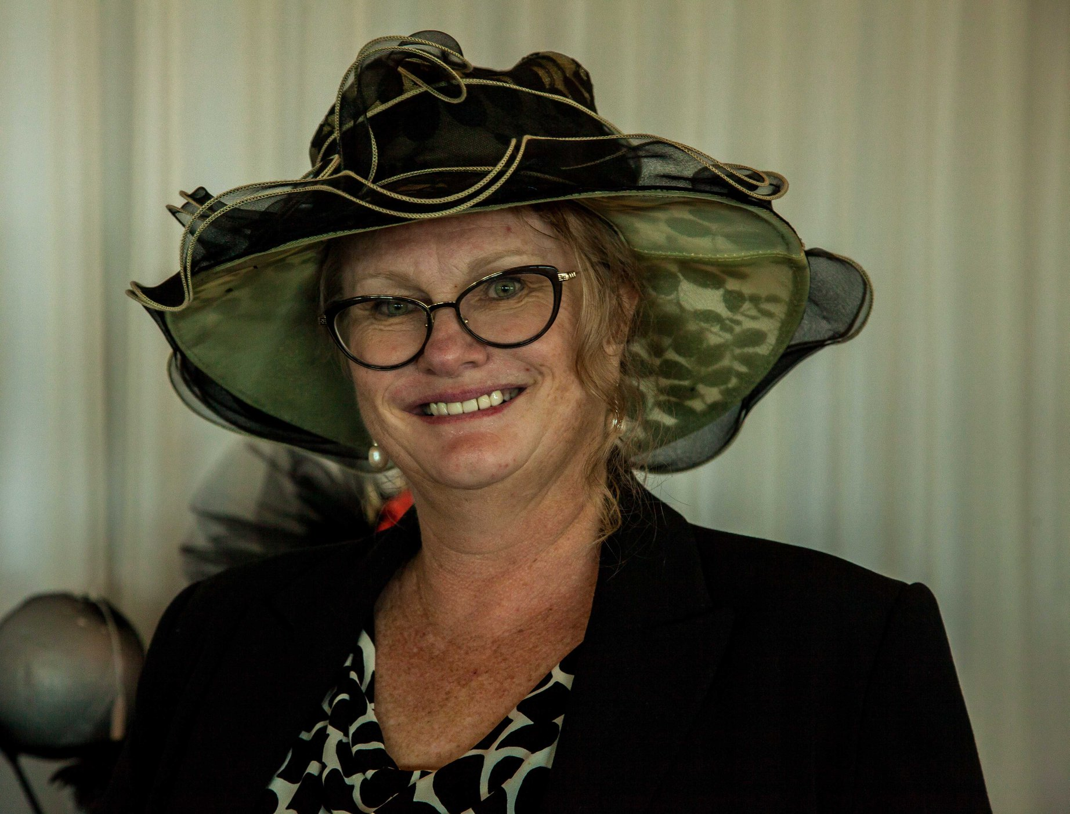

**Dinner Meeting April 2021**

President Nicole Redmond welcomed us to country & paid our respects for local elders, present past and emerging. She also welcomed a visitor, Ann Thomas, from Ella Bache Cleveland. Therese asked the meaning of Zonta and was told it is from a Sioux Indian language and means" honest and trustworthy”.

Therese thanked the club for making and donating breast cushions and Ange Hill demonstrated how the cushion pads were worn.

Robyn Smith has kindly offered to embroider Z for Zonta on the breast cushions.

Loris suggested a Breast care nurse could come and give a talk at one of our meetings.

After general discussion, the President proposed that the annual dues be $170.00 and that they be paid before the AGM on May 10th, and that election to go ahead on this basis.

**Nominating Committee News**

A vote was conducted on the recommendations of the nominating committee and there being no other nominations the following members were elected for the 2021/23 biennium.

President Pat Lavelle

Ist Vice President Julie Cardiff

2nd Vice President Robyn Smith

Secretary Carol Macdonald

Treasurer Helen Wood

Board Members Marilyn Smith

Therese Thorp

Jenny McIntosh

Loris Neff

With Judith Trevan-Hawke ex officio

Julie Cardiff Nominated the following 3 members for the Nominating Committee for 2021-2022

Janet Mylne, Jo Hieatt and Nicki Redmond

There being no further nominations, these members were duly elected.

At the AGM on 10th May 2021, the new Board will be installed, and the nominating Committee will be appointed.

**Membership** **News** Julie Cardiff

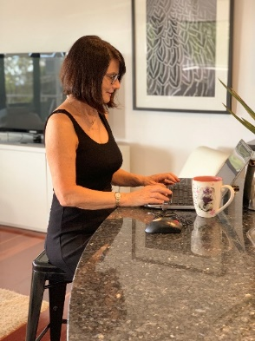

Julie told the group we are sorry to lose members Liz Jones and Michelle Francis.

Liz Jones has resigned however she wants to keep in contact with any functions we have.

Michelle has kindly offered to continue to maintain the Zonta WR webpage for us. It is heartening that although Liz and Michelle are not able to be active members they wish to stay in contact with the club.

We were all delighted with the news that our member and past DG Judith has been honoured with a Doctorate by the James Cook University. Please see the Citation in full at the end of the newsletter. Congratulations, Judith, we all know you are an exceptional woman, but this public acknowledgment is well deserved.

.**Service** **News** Pat Lavelle

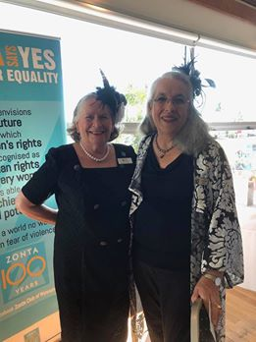

Plans are well advanced for our 1 June Gala Lunch at the RQYS. The Black and White and Red lunch is open on Trybooking and we sold 7 tickets in the first two days. Please ask your friends a family to come along and enjoy a day of Music, Fashion and Fellowship. Guests can dress to the theme if they wish, and we will have a prize for the best dressed. Ingrid, the violinist, is to play for us and I, for one, cannot wait to see how beautifully she is dressed.

We will be welcomed to the event at 10am by “Mates Rates”, a barbershop quartet, who assure me they will sing songs we can enjoy. Pauline from Labels by the Bay will be looking for some models soon for her beautiful clothes.

Please think about raffles prizes and bring them along to the May meeting if appropriate or contact Barbara on 0419 646 537.

Xmas In July is to be a club fellowship event with numbers restricted to 40.

Mary from the Courthouse has confirmed that we will be operating the Sweeps and Raffles for their Melbourne Cup Luncheon.

Saturday, 26th September to celebrate our 40th Anniversary, is booked in for a High Tea at Ormiston House. (50-70 guests can attend at this time due to COVID restrictions) We would like a strong attendance from past members and will be looking to contact as many as possible soon.

**Advocacy News** Therese Thorp

It is very important that we, as a club, support the joint initiative of Zonta, Soroptimist, Red Rose Foundation and Redland City Council in the Candle Lighting Ceremony at Walk the Talk on 5th May. Please wear your Zonta T shirts and be at Kyling Corner at 4.45. Details at the end of this newsletter.

**Zonta Club of Wynnum Redland Board**

|  |  |  |  |
| --- | --- | --- | --- |
| **President:** | | | Nicole Redmond [nickie1@ozemail.com.au](mailto:nickie1@ozemail.com.au) |
|  | | |  |
| **First Vice President:**  **Second Vice President:** | | | Pat Lavelle [patjane1@hotmail.com](https://d.docs.live.net/071df33e835e1c68/docs/Zonta%20Newsletters/patjane1@hotmail.com)  Julie Cardiff julie@cardifflaw.com.au |
| **Correspondence Secretary:** |  |  | Marilyn Smith damj382@hotmail.com |
| **Treasurers:** |  |  | Ros Beveridge [handlyn8@bigpond.com](https://d.docs.live.net/071df33e835e1c68/docs/Zonta%20Newsletters/handlyn8@bigpond.com)  Helen Wood helen.wood@firstclassaccounts.com |
| **Board Members:** |  |  | Judith Trevan-Hawke pujt@bigpond.com  (ex officio)  Sue Freilich suefreilich@gmail.com  Therese Thorp Secrets4women@bigpond.com  Jennie MacIntosh [jennie@kmsmith.com.au](mailto:jennie@kmsmith.com.au)  Robyn Smith [robynsmith.rs64@gmail.com](mailto:robynsmith.rs64@gmail.com) |



**Date Claimers**

|  |  |  |
| --- | --- | --- |
| **February** | 8th  22nd | Dinner Meeting Fiction Bar  Board Meeting Fiction Bar |
| **March** | 4th  8th  11th  29th | IWD Dinner and Presentation of YWPA award Courthouse Restaurant  Dinner Meeting Fiction Bar  Breast Cushion Working Bee  Board Meeting |
| **April** | 4th  12th  18th  26th | Easter Sunday  Dinner Meeting  Quota Changeover  Board Meeting |
| **May** | 4th  5th  10th  31st | Area 3 Meeting Nerang RSL  Walk The Talk Cleveland See Flyer Attached  Dinner Meeting Fiction Bar  Board Meeting |
| **June** | 1st  14th  27th  28th | Gala Lunch RQYS  Dinner Meeting Fiction Bar  Trivia Afternoon tea ?  Board Meeting |
| **July** | 12th  25th | Dinner Meeting  Christmas in July |
| **August** | 9th  30th | Dinner Meeting  Board Meeting |
| **September** | 4/5th  13th  26th  27th | District Conference Mackay  HouseDinner Meeting  40th Anniversay Ormiston House  Board Meeting |
| **October** | 11th  25th | Dinner Meeting  Board Meeting |
| **November** | 2nd 8th  29th | Melbourne Cup Day Courthouse  Dinner Meeting  Board Meeting |
| **December** | 11th  13th | Christmas Lunch Little Ships Club  Dinner Meeting |

|  |  |  |  |  |
| --- | --- | --- | --- | --- |
| Dr Judith Trevan-Hawke has been admitted to the award of Honorary Doctor of Science in recognition of her significant contribution to enhancing the capacity and capability of the Allied Health workforce, particularly Occupational Therapy, in northern Queensland.  **Citation for the Award of Honorary Doctor of Science (HonDSc), Dr Judith Trevan-Hawke**  James Cook University recognises Dr Judith Trevan-Hawke for her significant contribution to enhancing the capacity and capability of the Allied Health workforce, particularly Occupational Therapy, in northern Queensland.  As Associate Professor and foundation Head of the Department of Occupational Therapy at James Cook University (JCU), Judith Trevan-Hawke provided outstanding leadership and service to the development of Occupational Therapy at JCU and to the broader Occupational Therapy profession in northern Queensland.  Dr Trevan-Hawke joined JCU in 1997 and her first task was to establish an undergraduate Occupational Therapy program. Establishing such a program at JCU was a significant challenge. At the time, JCU had a limited number of health professional undergraduate programs and had recently consolidated its existing disciplines of Biomedical Sciences, Sports/Physiological Sciences, Nursing Science, Public Health and the Anton Breinl Centre for Tropical Health and Medicine into the Faculty of Health, Life and Molecular Science. With no existing Occupational Therapy presence at JCU, Dr Trevan-Hawke was responsible for the de novo development of a sustainable and locally relevant Occupational Therapy program for JCU within the Faculty of Health, Life and Molecular Science. This included recruitment of teaching staff, development of curricula, obtaining accreditation from relevant bodies and liaising with public and private Occupational Therapy providers to secure appropriate clinical placements for JCU students. In 1998, less than a year since her commencement at JCU, JCU launched its Bachelor of Occupational Therapy and in 2002, 43 students became the first graduates of the program. In 2001, the Occupational Therapy Honours program was introduced.  To date, there have been over 900 Occupational Therapy graduates, with these graduates forming an integral part of the northern Queensland health workforce. Dr Trevan-Hawke’s outstanding leadership and service was integral to the successful establishment and growth of Occupational Therapy at JCU and has provided a strong foundation for JCU's continued excellence in regional, rural and remote health education.  Dr Trevan-Hawke also has a long history of service to the broader Occupational Therapy profession in Queensland. Across her career, Dr Trevan-Hawke has represented the occupational therapy profession in many varied capacities, including: President and Vice President of the Queensland Association of Occupational Therapists (QAOT); the Australian Association of Occupational Therapist (AAOT) (Qld); representative to the Medical Faculty Board at The University of Queensland; and foundation member of the Queensland Council of Allied Health Professionals (chairing this council from 1992 to 1994). Dr Trevan-Hawke was appointed in 1990 to the Occupational Therapists Board of Queensland, becoming Chair of the Board in 1992 and remaining in this position until 2004. She was also a member of the Occupational Therapy Panel for the National Office of Overseas Skills Recognition (NOOSR) in Canberra from 1991 to 2000. Dr Trevan-Hawke has published widely and presented at many state, national and international conferences. In recognition of her outstanding service to the occupational therapy profession in Queensland, in 1994 she was awarded the Mary Rankine Wilson Memorial Award, the foremost award of Occupational Therapy Australia – Qld Division. |  |  |  |  |

**Remember,**

**Throughout Australia those who have died because of Domestic and Family Violence**

**Wednesday 5 May 2021, 5.30pm**

**Raby Bay Harbour Park,Shore Street West, Cleveland**

***No RSVP required***

**INVITATION**

**Candle Lighting Vigil**

**In Australia at least one woman is killed every week by an intimate partner. Often children and men are also the victims of these homicides. Each May the nation stops to remember those lost to domestic and family violence. The Candle Lighting Vigil is a respectful ceremony supported by state, and local government, police and local domestic and family violence services.**

**Date: Wednesday 5 May, 2021**

**Time: 5.30pm**

**Venue: Raby Bay Harbour Park,**

**Shore Street West, Cleveland**

**Walk the Talk walk**

**Join the Zonta Club of Wynnum Redland Inc and Soroptimists**

**from Bayside to walk united to the Candle Lighting Vigil to**

**show your support to eliminate domestic and family violence.**

**4.45pm – Meet at Kyling Corner (Cnr Waterloo & Middle**

**streets, Cleveland)**

**5.00pm – Walk as a united group to Raby Bay Harbour Park,**

**Cleveland**

**5.30pm – Attend the Candle Lighting Vigil to remember**