**The Zonta Club of Wynnum Redland Inc**.

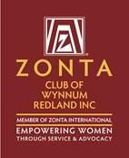

ABN: 57025338425

PO Box 132 Capalaba 4157

wynnumredland@zontadistrict22.org

Zonta International District 22, Area 3

**C conviction, C commitment, C courage**

**Find us on Facebook:** [**https://www.facebook.com/Zonta-Club-of-Wynnum**https://www.facebook.com/Zonta-Club-of-Wynnum-Redland-Inc-240575512649766/**Redland-Inc-240575512649766/**](https://www.facebook.com/Zonta-Club-of-Wynnum-Redland-Inc-240575512649766/)

February 2021

*Details:*

The next dinner meeting is 8th February at Fiction Bar, Raby Bay - [6pm](outlook-data-detector://3) for [6:30pm](outlook-data-detector://4). Cost for the dinner meeting is $30 with payment made electronically to bank account: BSB 633000 Acc [158165050](tel:158165050) .  
RSVP is **NOW** with payment and any dietary needs to club treasurer Ros Beveridge ([handlyn8@bigpond.com.au](mailto:handlyn8@bigpond.com.au)).

**PLEASE NOTE.**

**Failure to apologise to Ros before Friday 5pm will be assumed an acceptance and a meal will be provided. So, the cost of this meal will have to be met by the non-attending member as the Club cannot afford to pay any more than the Fiction Bar who bill us on numbers supplied**.

President Nicola Redmond

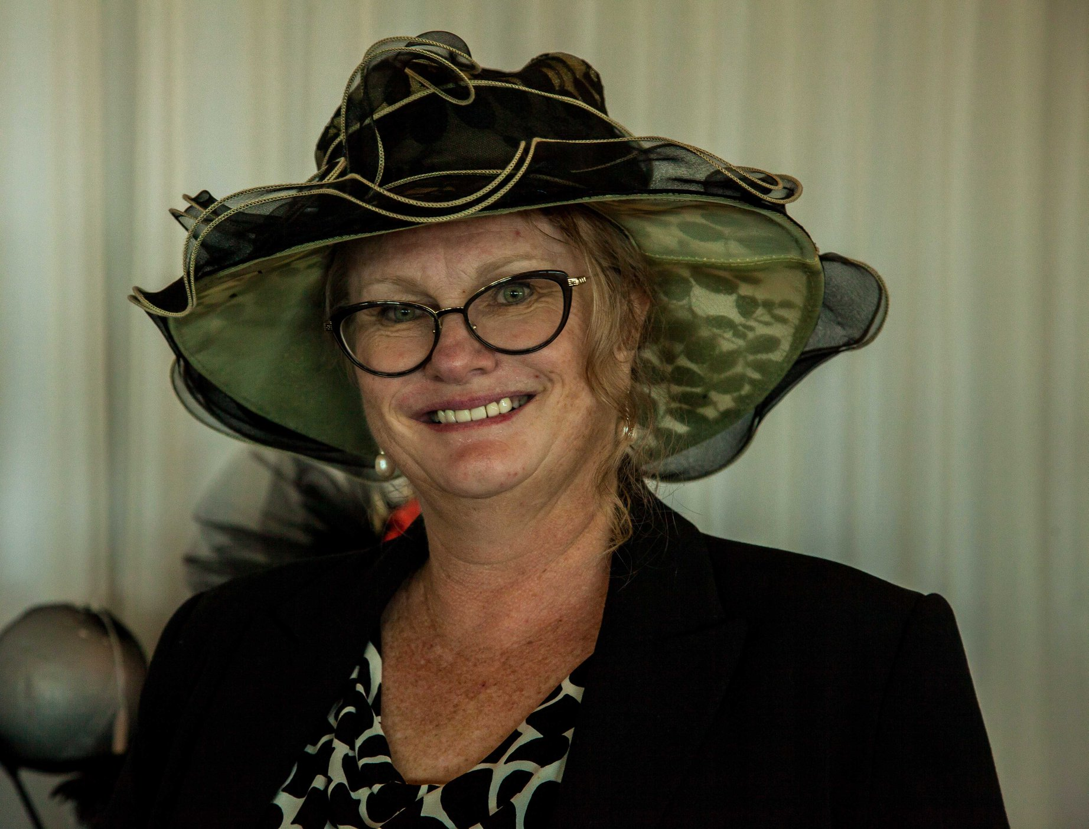

**Dinner Meeting December 2020**

President Nicole Redmond. Welcomed us to country & paid our respects for local elders, present past and emerging. Discussion regarding planning meeting, Barbara Wills said that she had sent out an email to the Area Director Jo Diessel, asking for Jo’s advice and possibly her presence at our meeting to be held on the 11th of January to plan for the year 2021. Jo had responded, apologising that she would be away.

Therese asked if there were any requests for more T-Shirts as she is able to purchase more?

In May we would like to commit to doing the "Walk the Talk” during the month of activism, where wearing the Orange T-shirts is advisable. Please contact Therese if you would like to order a T-Shirt. Pat advised the next meeting will be to plan for the year 2021 to be held at the Fiction Bar, on January 11th @ 6.30pm.

Janet Mylne and Robyn Smith will look for applicants for the Young Women in Business.

Mary offered to advertise for the IWD dinner on her website.

Barbara Wills suggested that we use Tri-Booking again as we have found this to be a more accurate way of keeping tabs on who’s coming and also payment has to made when booking.

Carol reported that there was a unanimous decision to support "The Love Bites programme”, as members were invited to vote per way of email, to facilitate a fast reply to Nikki Lacey’s (Clinical Nurse, Children’s Health Qld) request for our sponsorship.

So, we agreed to pay for 4x sessions costing $495.00 and one session for training the teachers of $200.00.

We will now await invoices to pay for these training sessions when the new school year arrives.

**Planning Day 2021**

After a one-week postponement due to COVID concerns we met on 18th January. Great attendance, 25 members were welcomed by First Vice Pat Lavelle and President Nicola Redmond

Carol MacDonald is to attend Grant Writing Workshop as advertised by RCC.

All agreed that primary need is for the club to improve communication. Within the club and with the general community. Resources to be used:

1. Webpage
2. Newsletter
3. Facebook
4. Twitter
5. Instagram

Some discussion was held as to the access to the ZI website and the District 22 Website. General feeling was that Zonta WR should have a lot of the information accumulated for tonight’s meeting freely available to club members.

The members agreed that most of the club’s traditional activities should be retained:

1. YWPA
2. Developing a greater interest in JM Klausmann award
3. Supporting Silky Oaks and Maybanke financially and in kind
4. Love Bites

Great interest was shown in hands on projects breast cushions, drainage bag covers and birthing kits. Margaret, Marilyn and Robyn S possible committee? Suggestion of using Birthing kits as a means of communication with schools by including students in community activity, Wellington Point High? With YWPA in mind.

Judith reminded us that club interests such as assistance to the Mental Health Unit at Redlands Hospital and the provision of the Survivors afternoon tea at the Relay for Life should be considered as advocacy as they do not meet ZI guidelines.

Therese showed a copy of the Zonta says No signage to go into toilets and has undertaken to order club cards.

General agreement that every member should be on a committee and contribute.

Signs at sports fields were mentioned as a successful venture.

Plans for a marketing plan for the Club going forward, marketing committee to be established with input expected from individual members. Julie, Irene, Michelle and Loris interested in setting up marketing plan.

Suggestion that we have social event of Crazy Whist as a fellowship/fun event for club members, partners, and friends.

Reminder that 2021 is the 40th Anniversary of our club and a special celebration should be planned.

Actions:

1. Marketing committee to formed and marketing plan established. Julie, Irene, Michelle, Ange and Loris to initiate.
2. Therese to order business cards for club and contact RCC re the placement of Zonta says NO displays in ladies’ toilets.
3. Pat and functions committee (Gail, Janet, Judith and Barbara) to set up timetable for this year’s functions. Including at least one weekend social event for members, partners and friends.
4. Michelle to update Zonta WR webpage to include information supplied by Judith and Loris.
5. Registry of club assets to be set up and location of club assets to be recorded.
6. Committee to be established to coordinate breast cushion/drainage bags and birthing kits preparation and timetable. Margaret? to lead members as available.

**Membership News** Julie Cardiff

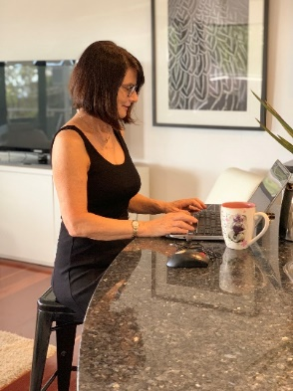

Julie welcomed the formation of a marketing plan for Zonta WR and will work with Irene and Michelle to bring this to fruition. A reminder to all club members that IWD dinner is a good way to introduce possible future members to Zonta.

**Marilyn’s Birthday Party.**

Marilyn would like to invite club members to her birthday party on the 20th of February. The party is at her NEW home at 382 Mt Cotton Road Capalaba. Please come along at 2.30 pm for an afternoon of fun with Crazy Whist the entertainment. Just let Marilyn know you are coming by the 16th of Feb on 0411723099 or [damj382@hotmail.com](mailto:damj382@hotmail.com). (BYO drinks) Marilyn says no birthday presents!

**Service** **News** Pat Lavelle

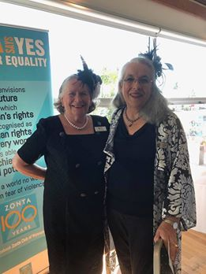

Our IWD dinner is coming up quickly. Tickets are now available on Trybooking. Partners and guests are welcome. After the very successful planning meeting, we are currently planning the function/social calendar for 2021. Looking at three or four Functions with a few purely social events to promote club fellowship. 2021 being the 40th anniversary of the Zonta Club of Wynnum Redland Inc we need a suitable celebration all suggestions will be welcomed.

**Advocacy**

Carrol Jackson moved Zonta Wynnum Redlands should purchase 50 brochures that promote awareness of ‘domestic Violence’, and she will arrange distribution.

Therese showed a copy of the Zonta says No signage to go into toilets and has undertaken to order club cards. She will liaise with RCC to place these in appropriate positions.

**Communication**

Michelle sent out asurvey before the planning meeting to get feed back on members feelings about our club

Here are the results from our survey;

12 Responders in total. As a summary, I think the survey was a positive ‘check-in’ for us. It seems like increasing our education for members will be a positive thing, and also increasing our clubs’ awareness to the public. Most members, myself included, did not know of Zonta before they were referred by a friend or family member. Maybe we could look into some marketing for our club?

**Please tell us why you decided to join Zonta?**

Most people shared that they joined Zonta as a way to serve the community and help women.

- “Looking for a way to contribute to our community and meet like-minded people”.

- “I thought it was a great club as it does so much for women”.

**Which of the Three Pillars of Zonta do you feel most aligned to?**

7 people felt most aligned with our Service Pillar, 4 to Membership and only 1 to Advocacy.

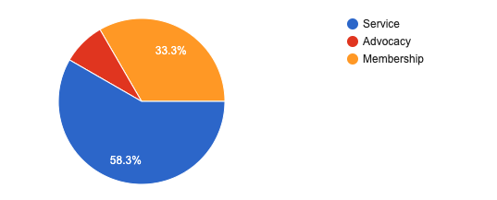

**What opinions or expectations did you have of Zonta as an organisation before joining Zonta Wynnum Redlands?**

Most people were referred to Zonta by a personal friend or by somebody already as a member but had no other idea or understanding of who we are or what Zonta does.

- “None. Had not heard of it until I was invited to a dinner meeting”.

- “I expected a service club like Rotary but with a female focus”.

- “Went ahead with an open mind”.

**Has our club, Zonta Wynnum Redlands met your expectations?**

The vast majority are pleased with Zonta and feel the club is matching their expectations.

- “Yes, and way, way more”

- “Yes, I feel we have been held back this year by the pandemic but thank goodness for Zoom”.

- “If I am honest not initially but over the last 12 months I have come to enjoy the experience of being a member”

**Please share a few things about our club that you especially enjoy or feel positively about.**

All responders shared something lovely about the club and the most positive emotion shared amongst the responders is the feeling of fellowship and togetherness felt in our club.

- “Fellowship within club and other clubs”

- “Probably the friendships that are gained with other members”.

- “I enjoy the fundraising functions and the increasing camaraderie now the long-standing members are getting to know me”

**Do you feel that Zonta Wynnum Redlands is active enough in the below areas?**

In regards to our clubs’ activity in Community Service, Women's Advocacy, Awareness Programs, Education Programs and Promoting the Zonta Message, most responders believed we are active enough in Community Service and Women's Advocacy, we had few responders believe we are active enough in Awareness Programs.

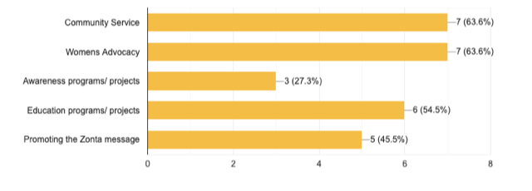

**Do we need more education around what is expected of Zonta Members and Board Members?**

91% of responders believed we need more education around what is expected of Zonta members and board members.

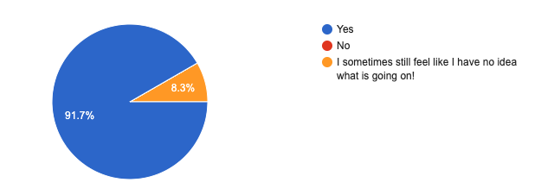

**Zonta Wynnum Redlands currently has three fundraisers per year - Two lunches and one dinner. Should we broaden our focus to include partners and friends more?**

Over 70% of responders believed we should broaden our fundraisers’ focus to include partners and friends more.

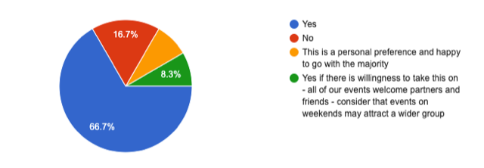

**Do you feel that Zonta Wynnum Redlands supports other service clubs who support us enough?**

75% of responders believed we, as a club, sufficiently support local service clubs who support us.

**Would you be interested in participating in more hands-on projects for Zonta?**

Over 63% of responders would be willing to participate in more support projects on behalf of Zonta.

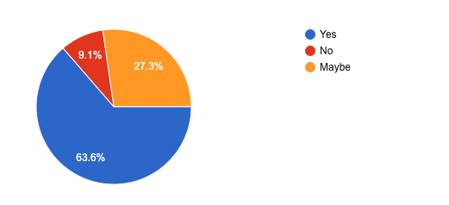

**Would you be interested in participating in marketing and helping to promote the Zonta message?**

While only 41% of responders said they would be willing to participate in marketing to help Zonta, another 41% suggested ‘maybe’ as well.

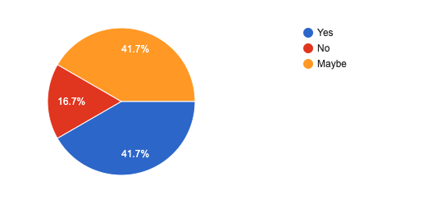

Date Claimers –

8 February Dinner Meeting Fiction Bar

4 March 2021 IWD Courthouse

4/5 September District 22 Conference Mackay

|  |  |  |  |  |
| --- | --- | --- | --- | --- |
|  |  |  |  |  |

**Zonta Club of Wynnum Redland Board**

|  |  |  |  |
| --- | --- | --- | --- |
| **President:** | | | Nicole Redmond [nickie1@ozemail.com.au](mailto:nickie1@ozemail.com.au) |
|  | | |  |
| **First Vice President:**  **Second Vice President:** | | | Pat Lavelle [patjane1@hotmail.com](https://d.docs.live.net/071df33e835e1c68/docs/Zonta%20Newsletters/patjane1@hotmail.com)  Julie Cardiff julie@cardifflaw.com.au |
|  | | |  |
| **Secretary:** | | | |  | | --- | | Carol MacDonald caroljmacdonald@icloud.com | |  | |
| **Correspondence Secretary:** |  |  | Marilyn Smith damj382@hotmail.com |
| **Treasurers:** |  |  | Ros Beveridge [handlyn8@bigpond.com](https://d.docs.live.net/071df33e835e1c68/docs/Zonta%20Newsletters/handlyn8@bigpond.com)  Helen Wood helen.wood@firstclassaccounts.com |
| **Board Members:** |  |  | Judith Trevan-Hawke pujt@bigpond.com  (ex officio)  Sue Freilich suefreilich@gmail.com  Therese Thorp Secrets4women@bigpond.com  Jennie MacIntosh [jennie@kmsmith.com.au](mailto:jennie@kmsmith.com.au) |

**And my thought for today!! (I’m working on this one)**

