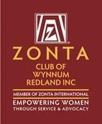The Zonta Club of Wynnum Redland Inc.
ABN: 57025338425
PO Box 132 Capalaba 4157
wynnumredland@zontadistrict22.org
Zonta International District 22, Area 3
C conviction, C commitment, C courage
Find us on Facebook: https://www.facebook.com/Zonta-Club-of-Wynnumhttps://www.facebook.com/Zonta-Club-of-Wynnum-Redland-Inc-240575512649766/Redland-Inc-240575512649766/
April 2021

Details:
The next dinner meeting is 12th April at Fiction Bar, Raby Bay - 6pm for 6:30pm. Cost for the dinner meeting is $30 with payment made electronically to bank account: BSB 633000 Acc 158165050 .
RSVP is NOW with payment and any dietary needs to club treasurer HELEN WOOD <helen.wood@firstclassaccounts.com>).
PLEASE NOTE.
Failure to apologise to Helen before Friday 5pm will be assumed an acceptance and a meal will be provided. So, the cost of this meal will have to be met by the non-attending member as the Club cannot afford to pay any more than the Fiction Bar who bill us on numbers supplied.

President Nicola Redmond
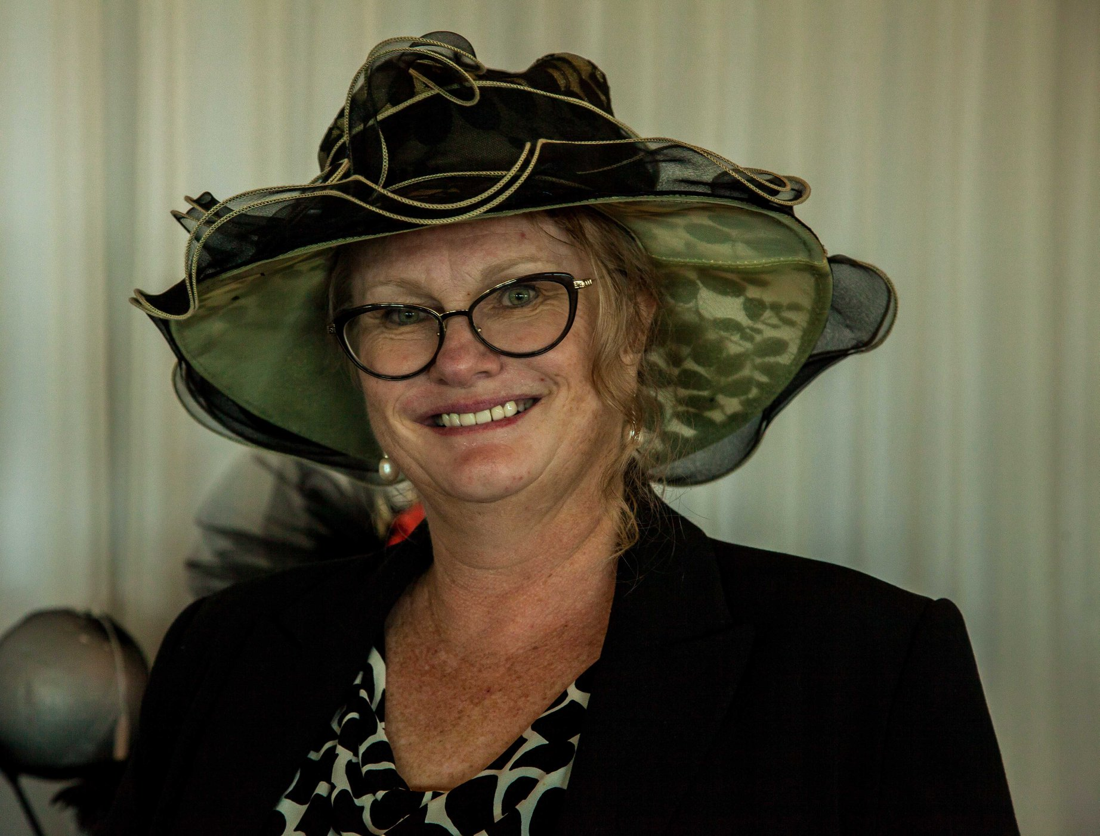
Dinner Meeting March2021

President Nicole Redmond. Welcomed us to country & paid our respects for local elders, present past and emerging.
we have received a n email from jo Diesel who is Area Director Area 3 from District 22. She asked if any of us could provide accommodation is required for the Area 3 meeting on May 8th? The venue has yet to be decided.
Irene Henley (1), Barbara Wills (2) and Carol MacDonald (2) all offered accommodation if required.
Irene Henley gave an excellent talk on Marketing for Zonta, using models provided by Zonta international. Irene spoke about road maps to cover Social Media, Data Base, & Public Relations. This is the start of working towards attracting more members and in the process, building a bigger group.
Michelle arranged for the club to have business cards, where members could write their names on them when giving them out. These were distributed.
Helen Wood kindly gave a remarkably interesting talk on her life as an accountant.
Angela gave a brief report on the Facebook and how it has grown with the number of likes.
Nominating Committee News
Our Nominating Committee, Gail Abbott, Jo Hieatt and chair, Janet Mylne, produced a slate of candidates for the 2021/23 biennium.
President Pat Lavelle
Ist Vice President Julie Cardiff
2nd Vice President Robyn Smith
Secretary Carol Macdonald
Treasurer Helen Wood
Board Members Marilyn Smith
Therese Thorp
Jenny McIntosh
Loris Neff
With Judith Trevan-Hawke ex officio
The election will be held during the April Dinner Meeting.

Membership News Julie Cardiff
Julie told the group we are sorry to lose Meredith Newman as a member, as she has resigned.
Liz Jones Brought a guest along, Sue Reissen and Julie welcomed Susan.
YWPA News
The YWPA committee were very pleased to report that our runners up have been placed with other clubs so three young women have been recognised for their contributions to the community.
.Service News Pat Lavelle
Pat gave a report on the IWD event and said that she was sorry that we did not give a special thanks to the sponsors on the night, however, they were mentioned on the back of the agenda on the night and will be thanked on our Facebook page, as well as on our next Newsletter.
The next fund-raising event will be held at The Manly Yacht Squadron in June. Barbara Wills had suggested Pretty In Pink, but this was not met with approval so it will now be called The Black, White and Red all over. This gives guests the opportunity to dress up if they wish. We have arranged an author, Alan Finegan, as our guest speaker. Alan has written a book about the colonial history of Moreton Bay. Labels by the Bay have kindly agreed to arrange a fashion parade and we will contact Panda Pearls again.
Xmas In July is another possible event, just have to check out possible venues.
Saturday 26th September to celebrate our 40th Anniversary, is pencilled in for a High Tea at Ormiston House. (50-70 guests can attend at this time due to COVID restrictions)
A successful Breast Cushion making day was held on the 11^{th of} March. We completed 11 cushions for distribution and are in train to make more. Robyn Smith has a great new sewing machine and plans on embroidering our Zonta Logo on future products.
Zonta Club of Wynnum Redland Board

President: |  |  | Nicole Redmond nickie1@ozemail.com.au
First Vice President:  Second Vice President: |  |  | Pat Lavelle patjane1@hotmail.com  Julie Cardiff julie@cardifflaw.com.au
Correspondence Secretary: |  |  | Marilyn Smith damj382@hotmail.com
Treasurers: |  |  | Ros Beveridge handlyn8@bigpond.com  Helen Wood helen.wood@firstclassaccounts.com
Board Members: |  |  | Judith Trevan-Hawke pujt@bigpond.com  (ex officio)  Sue Freilich suefreilich@gmail.com  Therese Thorp Secrets4women@bigpond.com  Jennie MacIntosh jennie@kmsmith.com.au  Robyn Smith robynsmith.rs64@gmail.com

Date Claimers
January | 18th  25th | Planning Day Fiction Bar  Board Meeting Zoom
February | 8th  22nd | Dinner Meeting Fiction Bar  Board Meeting Fiction Bar
March | 4th  8th  11th  29th | IWD Dinner and Presentation of YWPA award Courthouse Restaurant  Dinner Meeting Fiction Bar  Breast Cushion Working Bee  Board Meeting
April | 4th  ^{12th}  18th  26th | Easter Sunday  Dinner Meeting  Quota Changeover  Board Meeting
May | 4th  10th  ^{31st} | Area 3 Meeting Nerang RSL  Dinner Meeting Fiction Bar  Board Meeting
June | 1st  14th  ^{28th} | Gala Lunch RQYS  Dinner Meeting Fiction Bar  Board Meeting
July | 25th | Christmas in July?
August
September | 4/5th  26th | District 22 Conference Mackay  ZontaWR 40th Anniversary

