May 2019
I n c o r p o r a t i o n Nu m b e r: I A 1 8 3 3 2
C l u b No. 1 4 9 9
C ha r t e r e d 1 3. 0 2. 1 9 9 5
Area 2 Di s t r i c t 22
President’s Message:
Fellow Zontians,
A pleasant night of fellowship was had by all last Saturday evening and we thank Michelle and Craig for hosting at their place. The informal Zonta conversations had at such gatherings are as important as our meeting talks. All contribute to the well being of the club and the learning about Zonta which we gain by sharing.
This newsletter contains information about the Dianne Leggo honour roll. I would recommend everyone reads this as it will be talked about at Conference and we all need to “be in the know”.
I look forward to the changeover dinner as this event gives our club the opportunity to distribute funds to local groups thus spreading the word and the work of Zonta in our community. The instalment of the recently elected Board and the reorganisation of committees enables our club to move forward into the next, busy, Zonta year.
Once again, I wish to thank every member for your specific contribution to the year just passed and encourage each one to look forward to our centenary celebrations as well as our regular projects in this next year.
Yours in Zonta
Denise
MEETINGS Dinner Date: 28th March 2018, Time: 5.30pm Fellowship, 6pm Dinner, 6.45pm Meeting Venue: Blue Shades Committees: Membership, Public Relations, Program and Communications REMINDER 1st Wednesday of the Month, RSL – 6.00-7.00 If you are unable to attend Advocacy, United Nations the Dinner Meeting please 1st Wednesday of the Month, RSL, 5.00pm advise Michelle Byrne by Service, Finance and Fund Raising email or phone 0412779607 1st Wednesday of the Month, Westside Tavern18t, 5.30pm Board Date ^{2nd} Wednesday of the Month, Elizabeth Rossi’s Home, 5.30pm
DINNER RAFFLE DONATION
May – Bin, June – Meth, July - Nicole

BUDDIES  Michelle & Doreen, Joan & Elizabeth, Sandy & Vicki, Nshara & Denise, Bin & Alison G, Meth & Karen, Alison B & Anne K, Mona & Ann C, Dawn & Sharon  COMMITTEES Membership/Public Relations/Program and Communications Sharon (Chair), Michelle (Facebook and Web Manager), Alison B, Mona (Correspondence Secretary), Sandy (Newsletter)  Advocacy/United Nations Karen (Chair), Anne K, Alison G, Ann C (Minute Secretary), Dawn, Elizabeth (Director)  Service/Finance and Fundraising Vicki (Chair), Nshara (Vice President), Doreen, Bin, Meth (Treasurer), Joan Brazier (Director & Ass. Web Manager)  President – Denise |  | DATES TO REMEMBER  18th May Fellowship Michelle’s 5.30pm  15th June Change Over Dinner  6th - 8th September Combined District Conference Brisbane  28th 100 Year Celebration Rose Garden Maryborough  8th November – 100 Year Anniversary Dinner
Happy Birthday | Happy Birthday  Elizabeth 4th | District Conference 6th-8th September  Register now for early bird price  https://www.trybooking.com/book/event?eid=479031&.  Check out the Facebook page : https://www.facebook.com/events/2029897627320389/

Congratulations to our 2019 – 2020 Board
President: Denise Wilschut Vice President – Nshara Kington

Minute Secretary: Anne Kearse Corres. Secretary: Ann Chapman

Treasurer Directors
Alison Geerlings Elizabeth Rossi

Dianne Leggo Honour Roll

The D22 Board has approved the establishment of a District Governor Award – the Dianne Leggo Honour Roll. The Award will recognise and honour individual Zontians who have personified the ideals of Zonta at club level through their support and promotion of local projects and Zonta International. Typically, but not exclusively, the nominee would not have held a position on the District Board, but may have held leadership positions within their own club. This award is not specifically linked to length of service, but instead focuses on the quality of the member’s ongoing contribution to Zonta. It is expected that the nominee would have ‘gone above and beyond’ the expectations of membership and provided inspiration to other members through their service to Zonta and the community.
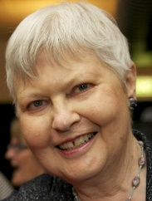
Dianne Leggo biography Dianne moved to Bundaberg, Queensland some thirty years ago. She organized the Zonta Club of Bundaberg and then travelled extensively throughout Queensland setting up Zonta Clubs. Dianne was the leader in organizing many Zonta Clubs in Central and Northern Queensland, namely Biloela, Bowen, Burdekin, Charters Towers, Emerald, Gladstone, Hervey Bay, Longreach, Mackay, Maryborough, Middlemount and Mount Isa. The Emerald, Biloela and Middlemount Clubs disbanded after making considerable contributions to their communities. Dianne also organized the Blackall Range and Northern Rivers (Lismore) Clubs. She was assisted in many cases by Mary Magee and Jane O’Brien. Overseas, Dianne organized the Calgary (Canada), Monterey (California), New Braunfels (Texas) and Dublin (Ireland) clubs. She spent six weeks in the USA training Zontians to establish new clubs and recruit and retain members in existing clubs.
Dianne is the person Zonta members turn to when there is a difficulty that needs an answer. She was on Zonta's International Membership Committee for four years and was International Chairman for another four years together with Jane O’Brien as Co-Chairman. She has always promoted the welfare of women and encouraged clubs to become involved with local women's shelters, helping with funding and amenities. She has strongly encouraged new clubs to support the Birthing Kit Foundation of Australia and to provide breast cushions for cancer sufferers. Because of her promotion of Zonta Clubs, Dianne has enhanced the lives of women. Through her fostering, clubs are aware that the health, safety and education of women are important issues they can further, while also having the joy of fellowship with other women.
Dianne embodies the values listed below:
- She has encouraged Zonta members to work together to promote the welfare of women.
- She has travelled to many parts of the world on her own, helping women unite for progress through their involvement with Zonta.
- She is a fund of new ideas and is always willing to try a new approach.
Dianne has shown great leadership not just in her own community but also throughout many communities in Queensland. Her energy and enterprise are the foundations on which many Zonta clubs were built.
Her work with Zonta has had a lasting effect on the lives of women and girls around the world. Her interests are not narrow. She was a key person on the “Relay for Life" Committee in Bundaberg and is a great supporter of local artists and performers.
Dianne is currently a member of the Zonta Club of Paradise Point Inc. on the Gold Coast.
Nominations are now called for the inclusion on the Dianne Leggo Honour Roll and the form below should be completed and returned to the District Governor no later that 6 weeks BEFORE Conference in September.
Guidelines for Nominations Dianne Leggo award

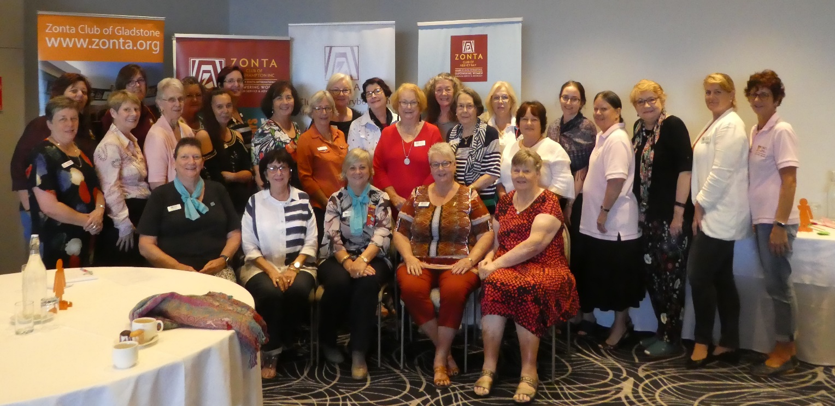
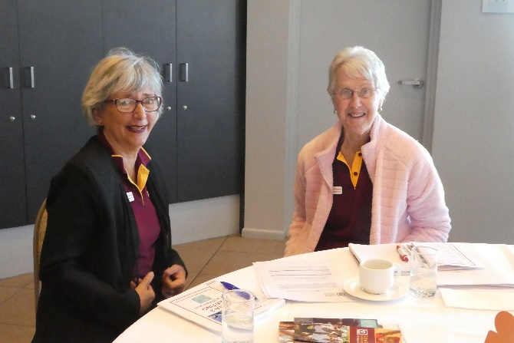
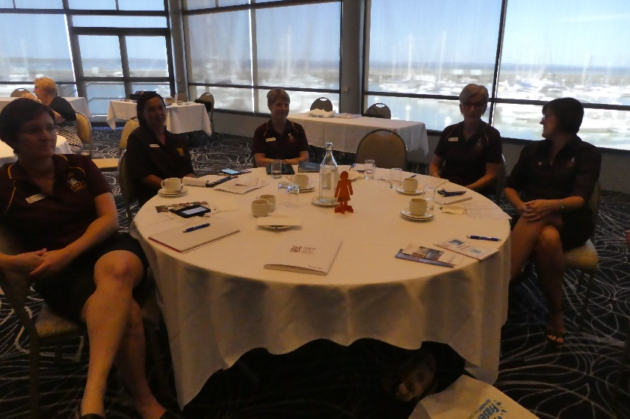
AREA 2 MEETING PHOTOS

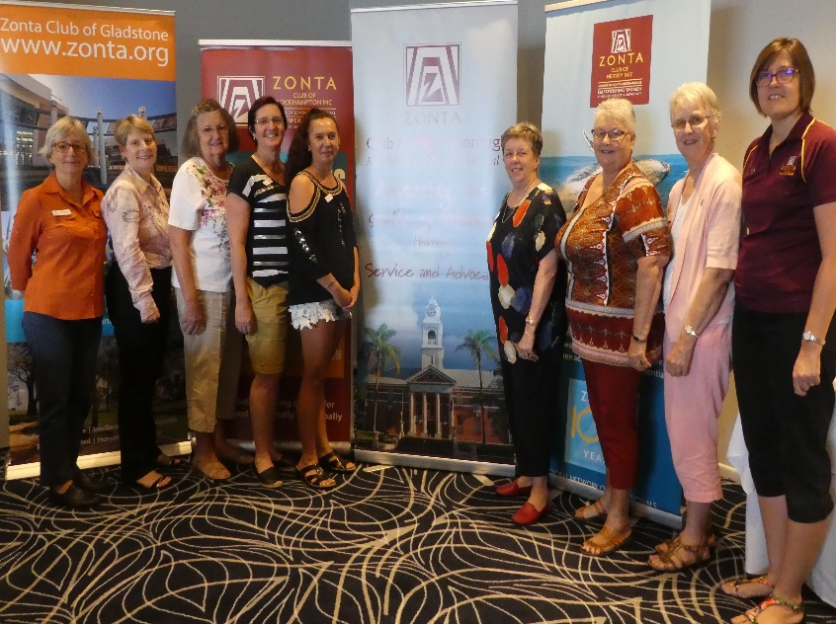
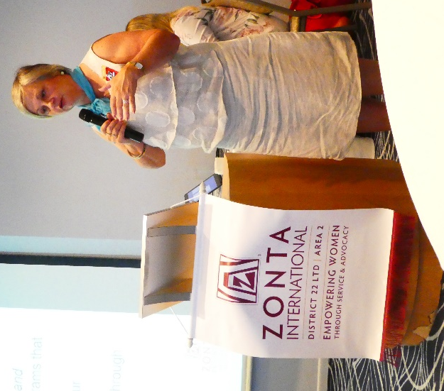

Bonfire Felllowship

President: Denise Wilschut denwils@bigpond.com
Email: zontamaryboroughqld@gmail.com
Maryborough Web Page: www.maryborough.zontadistrict22.org
District 22 Website: www.zontadistrict22.org
Zonta International Website: www.zonta.org

