

September 2018

I n c o r p o r a t i o n Nu m b e r: I A 1 8 3 3 2

C l u b No. 1 4 9 9

C ha r t e r e d 1 3. 0 2. 1 9 9 5

Area 2 Di s t r i c t 22

**President’s Message:**

|  |
| --- |
| Fellow Zontians,  I was pleased to receive the first  “Zontian” for this new biennium. It gives all of us, worldwide, an wonderful overview of the proposed work for the next two years. International projects, the new International Board  and lots, lots more. Along with others, I was surprised to see the change of Zonta colours and am hoping that the pale blue will enhance our traditional mahogany and gold. At least, the biennium will be specified by this focus. Meanwhile, locally, we have commenced with the great golf day and are well into planning the 16 days of activism. I’ve heard a whisper that prospective members are seeking to know more about Zonta and the on-going good work that is undertaken by our members. Well done everyone, Maryborough club is definitely contributing to the mission of ZI.  Yours in Zonta  Denise |

**MEETINGS Dinner Date**: 28th March 2018, Time: 5.30pm Fellowship, 6pm Dinner, 6.45pm Meeting **Venue**: Blue Shades **Committee**s: **Membership, Public Relations, Program and Communications** **REMINDER** 1st Wednesday of the Month, RSL – 6.00-7.00 If you are unable to attend **Advocacy, United Nations** the Dinner Meeting please 1st Wednesday of the Month, RSL, 5.00pm advise Michelle Byrne by **Service, Finance and Fund Raising** email or phone 0412779607 1st Wednesday of the Month, RSL, 5.30pm **Board Date** 2nd Wednesday of the Month, Margheriti’s Pizza, Custom House Hotel, 5.30pm

**DINNER RAFFLE DONATION**

September–Vicki, October– Rosalie AD 2016-2018, November- Doreen

|  |  |  |
| --- | --- | --- |
| BUDDIES  Michelle Byrne & Doreen Pearce, Joan Brazier & Elizabeth Rossi, Sandy Peters & Vicki Muller, Nshara Kingston & Denise Wilschut, Bin Xu & Alison Geerlings, Meth Youngberry & Karen Birt, Alison Bowman & Anne Kearse, Mona Egan and Ann Chapman, Dawn Vollmehause & Sharon Kirk  **COMMITTEES Membership/Public Relations/Program and Communications Sharon Kirk (Chair), Michelle Byrne (Facebook and Web Manager), Alison Bowman, Mona Egan (Correspondence Secretary), Sandy Peters (Newsletter)**  **Advocacy/United Nations Karen Birt (Chair), Anne Kearse, Alison Geerlings, Ann Chapman (Minute Secretary), Dawn Vollmehause, Elizabeth Rossi (Director)**  **Service/Finance and Fundraising Vicki Muller (Chair), Nshara Kingston (Vice President), Doreen Pearce, Bin Xu, Meth Youngberry (Treasurer), Joan Brazier (Director),**  **Preident – Denise Wilschut** | | **DATES TO REMEMBER**  **8th International Literacy Day** International Day of Peace **21 September 2018**  Each year the International Day of Peace is observed around the world on 21 September. The General Assembly has declared this as a day devoted to strengthening the ideals of peace, both within and among all nations and peoples.  **26th Meeting Night** |
| Happy Birthday | Happy Birthday to  Sharon 6th,  Karen 16th  Alison B. 18th | [International Day of the Girl Child](https://membership.zonta.org/Events/Details/international-day-of-the-girl-child-2) **On December 19, 2011, the United Nations General Assembly adopted Resolution 66/170 to declare 11 October as the International Day of the Girl Child, to recognize girls’ rights and the unique challenges girls face around the world.** |
| Centennial Anniversary Grants - $300,000 total – maximum $5000 to an organization – applications 15/9/18-31/3/2019C:\Users\Sandy Peters\Documents\Zonta 2018 Area 2 Meeting\P1050292 (2).JPG  See information below. | | |

**Have you been on the Zonta District 22 or ZI websites this month – perhaps you can tell us what you read at our monthly meeting.**

**https://zontadistrict22.org/member-resources/policies-manuals-tools/district-22/**

### Centennial Anniversary Grants

In honor of 100 years of Zonta service and Zonta International’s centennial anniversary in 2019, Zonta International has launched its Centennial Anniversary Grants program. These one-time grants of up to US$5,000 each will recognize charitable organizations working to improve the lives of women and girls in their local communities. Zonta International will award up to US$300,000 in grants to deserving organizations from any of [**the 63 countries**](https://www.zonta.org/Portals/0/Zonta/Zonta%20Countries.pdf) in which Zonta currently has active Zonta clubs.

<https://www.zonta.org/centennialgrants>

**ELIGIBILITY** Charitable organizations must partner with a local Zonta club to apply. The partnering organization must:Have registered charity/non-profit status, i.e. 501(c)(3) status in the US, or equivalent if outside the US, to prove the organization is allowed to collect donations and receive grants.

* Provide evidence that it complies with diversity standards.
* Provide evidence that it complies with health and safety standards.
* Propose a project that meets at least one of the objects of Zonta International - legal, political, economic, health, education, or violence against women.
* Propose a project that will be delivered in the Zonta club’s local community.
* Have a high reputation for its work in the Zonta club’s region/country.

**APPLICATIONS will be accepted from 15 September 2018 to 31 March 2019.**

Applications must be made through a Zonta club and submitted using the online application form. Hard copy and email applications will not be accepted. An organization may make only one application and cannot receive more than one grant in one country.

_________________________________________________________________________________________________________________________

Young Women in Public Affairs Award**** District 22 Awardee Madison Birtchnell has a proven track record of leadership within school through her roles as vice-captain, prefect, debating captain, public speaking captain, Amnesty International captain, EXO captain, business ambassador, debating and public speaking coach, chapel captain, pastoral care mentor and Student Representative Council Committee chair. She was also selected to shadow David Mackie, director general of the Department of Justice and Attorney-General, and has fundraised for ovarian cancer, Headspace, beyondblue, and the Red Cross.

Madison has been recognized by key justice and government figures for her initiative and passion serving others and was awarded Gold Coast Young Citizen of the Year 2018. As part of International Women’s Week, she organized and led a free community conference, which raised more than AU$1,200 (nearly US$900). More than 150 community members attended the empowering afternoon, designed to empower and inspire women and girls. Madison represents Queensland and Australia as an advocate and young leader in the Class of Women Deliver Young Leaders Global program. She also spent six years as a volunteer with Ormiston House and volunteered with Daughters of Promise, an organization that invests in the lives of young girls and women in communities. Madison is currently studying business management at the Queensland University of Technology. She has a passion to work in government and the United Nations, where she can have the most impact and create social change. She is inspired by Michael Kirby AC CMG, a former justice of the High Court of Australia, and hopes to one day create a legacy that inspires the next generation of community leaders and fosters an environment that realizes the potential of young people. Madison plans to continue to volunteer, serve others and positively contribute to her communities. Read More about the other 9 awardees - https://membership.zonta.org/News/Details/read-about-the-2018-ywpa-awardees

[](https://zontasaysno.com/)**A GREAT GOLF DAY**

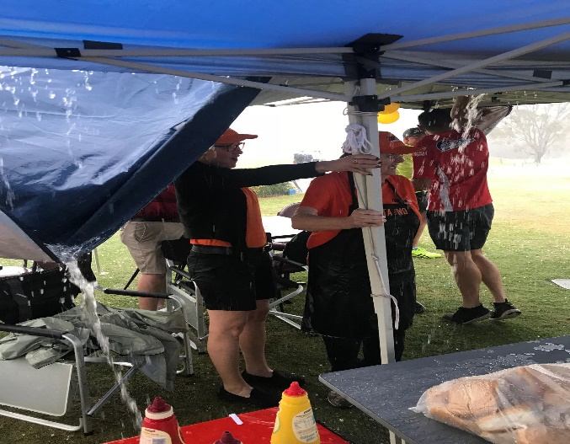 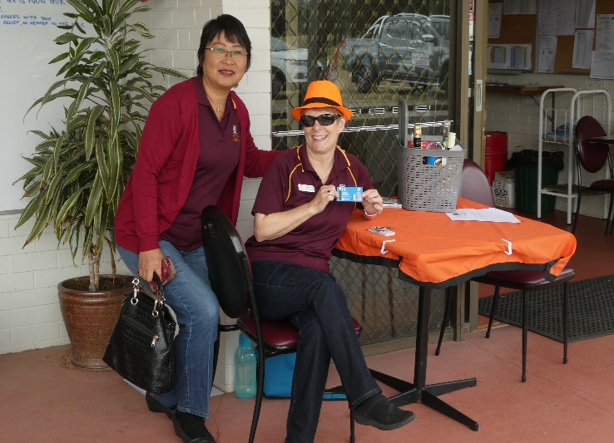

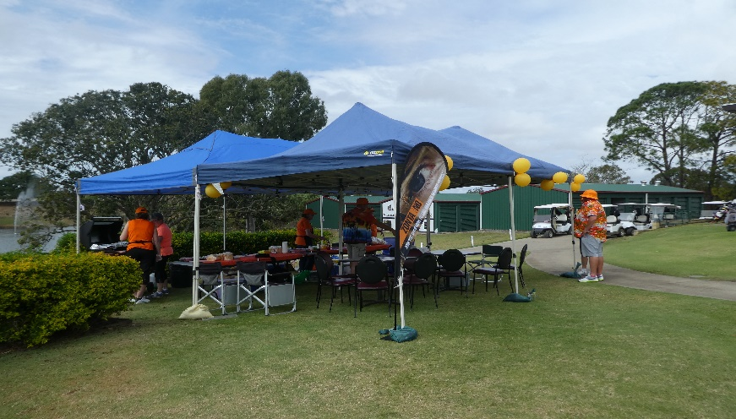 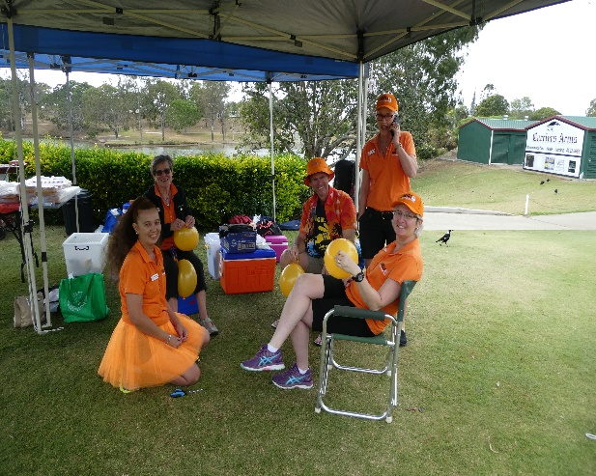 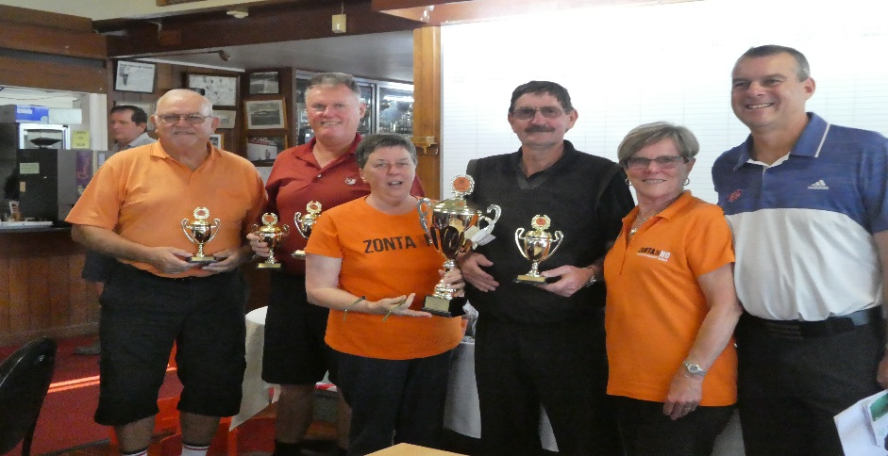 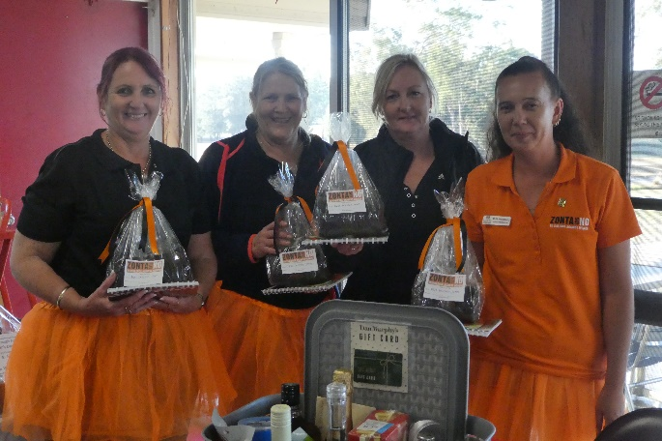

PO Box 1063 Maryborough Q 4650

President: Denise Wilschut denwils@bigpond.com

Email: zontamaryboroughqld@gmail.com

Maryborough Web Page: www.maryborough.zontadistrict22.org

District 22 Website: www.zontadistrict22.org

Zonta International Website: www.zonta.org

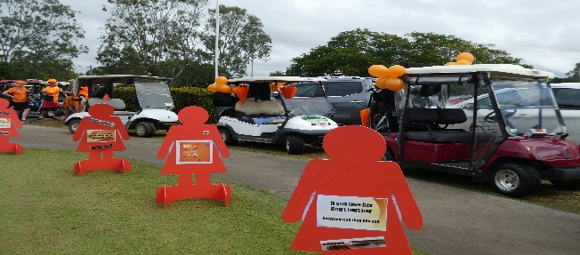

 I wish you all a happy new Zonta year. As we begin 2018, we also enter the last six months of the 2016-2018 Biennium.