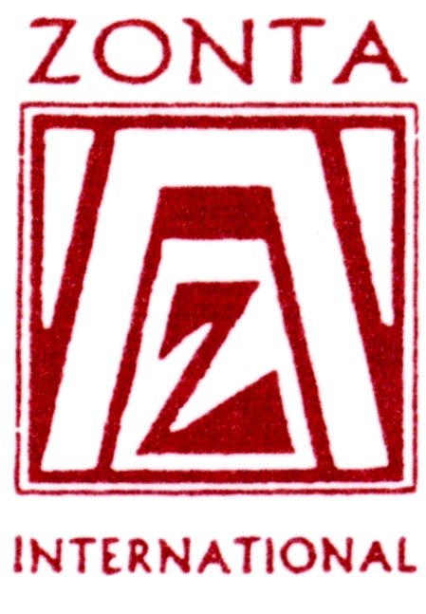

“Future Leaders Building a Better World Today”

Z and Golden Z Clubs

Sponsored by Zonta International

A worldwide service organisation of executives in business
and the professions working together to advance
the status of women.
What are Z Clubs and Golden Z
Clubs?

- The Z Club program is one of Zonta International’s service projects.
- Z clubs and Golden Z Clubs are organizations which provide opportunities for our youth to develop leadership skills, to explore career alternatives, and to improve international understanding through service projects.
- Z clubs are formed on secondary school campuses or in the community.
- Golden Z Clubs are established on college and university campuses.

Why Z Clubs and Golden Z Clubs?

- The youth of today will be the leaders of tomorrow. The Z and Golden Z Club program is a way for these future leaders to build a better world today.
- Actively participating in school, community and international affairs, club members can have a positive influence on the world around them.
- Young people are given an opportunity to interact with experienced Zonta sponsors.
- They work together to better their society and the world by gaining an understanding of their school and community, as well as an international awareness.

What are the benefits of
membership?

- Supporting school, community and international projects is one way for members to become well-educated individuals and learn the satisfaction of giving.
- Members work together in planning, organizing, and participating in activities.
- Members develop valuable communications skills.
- Members gain civic leadership experience and develop leadership skills.
- Members meet new friends
- Members network with Zonta members from a broad range of professional backgrounds, which assists in developing career alternatives.

How is a Z Club or Golden Z Club organized?

- A Zonta member will meet with a representative of the secondary school or college to negotiate a place for the club members to meet, a member of staff to act as “advisor” to club members and provide assistance when necessary, and to gain approval for the club to be established on campus.

(Note: the selection of the “advisor” is based on their interest in youth, their ability to guide and encourage Z and Golden Z Club members to develop and participate actively in projects, and their availability of time.)
- A sponsoring Zonta Club pays the Charter registration and yearly renewal fee to Zonta International.
- The Zonta Club and the Advisor identify and approach students with the Z or Golden Z Club concept. Together they work as a team to establish the club. A Z and Golden Z Club Manual is used as a guide to forming a new club.

History of Z Clubs and Golden Z Clubs

- The first Z Club started in Burbank, California in 1948. Within 10 years there were 12 Z Clubs and 3 Golden Z Clubs throughout the United States.
- Z Clubs became international in 1964 when a club was established in Ontario, Canada and in Lyon and Paris, France. Z Clubs were established in San Juan, Puerto Rico (1968), in Quezon City, Phillipines (1974), and in Hong Kong (1975).
- There are 3 Z Clubs in Australia in District 24. Z clubs are located at Ipswich Girls Grammar School (Qld), Ferny Grove State High School (Qld) and St Mary’s Start of the Sea College, Wollongong (NSW).

Service projects of Z Clubs and Golden Z Clubs

- These are selected at club level, with the focus on projects that benefit their schools, fellow students, their local community and the global community.
- Examples of school service projects conducted include tutoring other students, sponsoring a career night, assisting in beautification of the school grounds.
- Examples of community service projects include: volunteer time at women’s shelters or nursing homes, work to develop a youth centre, provide food and clothing for the needy and victims of fire and flood.
- Examples of international service projects include: promote cross-cultural communication via correspondence with pen pals, holding an “international” themed dinner to discuss international problems and promote international achievements, sponsor a foster child, offer Z Club membership to exchange students.

Recognition of Service in Z and Golden Z Clubs

- Service at the school, community, and international levels is recognized annually by Zonta International through the Emma L. Conlon Service Awards.
- Established in 1961, the awards were conceived and funded by Past Zonta International President Emma L. Conlon (1956-1958) as a way to encourage and to recognize exemplary service by young people.

For information about Z and Golden Z Clubs in Australia:

