AREA 3 DISTRICT 22

CHARTER DATE: 25 SEPTEMBER 1981
wynnumredlands@zontadistrict22.org
Zonta International Website: www.zonta.org

NEWSLETTER AUGUST 2011

PRESIDENT: | Mary Lou Podagiel |  | Home: | 3396 9947
MINUTES SECRETARY: | Diane Harmsworth |  | Home: | 5526 1487
CORRESPONDENCE: | Janet Mylne |  | Home: | 3399 3342
TREASURER: | Gail Abbott |  | Home: | 3849 3995
NEWSLETTER: | Debbie Clancy |  | Home: | 3893 3302
CALENDAR
September 21: | International Day of Peace
September 23 – 25: | District 22 Conference to be held in Brisbane
October 9: | 30th Birthday Celebration
October 24: | United Nations Day
DINNER MEETING DETAILS
Date: | 8TH August 2011
Time: | 6.30pm for a 7pm start
Venue | At the home of Barbara Wills – 42 Hardy Rd, Birkdale.
Please send apologies to Gail Abbott
Club policy confirmed that $2 admin is paid when an apology is given to the Treasurer by noon the Thursday prior to the dinner meeting. After that date $30 is due and an invoice will be sent.
THIS MONTHS BIRTHDAYS
Phyllis Pledger
Marilyn Steenland

Hope you have a happy day Ladies!!

PRESIDENTS REPORT – MARY LOU PODAGIEL
This month we have a very different and full dinner meeting at Barbara Wills home. Barbara has kindly donated her home and culinary skills to boost our Admin funds so the usual dinner charge will apply. Many thanks Barbara.
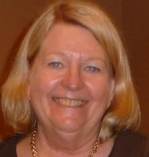On Saturday Diane Harmsworth, Gail Matthey and myself attended the Area 3 training day organised by our own Area 3 Director, Judith Trevan-Hawke, and hosted by the Zonta Club of Paradise Point. It was a very informative workshop analysing the role of the President and Treasurer and the new committee structure. The presentation that I found most fascinating was from the Guest Speaker, Kate Andrews from the Zonta Club of Brisbane Metro Breakfast. Her presentation “the importance of corporate memory and effectively moving ahead without recreating the wheel” was most relevant to government departments, large corporations and to Clubs like ours. We discussed ways in which the skills and expertise of CEOs, Department Heads, Club Presidents are retained and passed on, not lost and then time and effort is spent developing new or different policies and procedures to accomplish similar outcomes. Kate introduced us to a host of internet tools that could help us record history at a club level and then progress it to Area, then District to International. Kate suggested that creating a “WIKI” where all members could contribute their history would be a valuable asset and the sort of tool where younger members could assist the long standing members to upload their contribution. It was all food for thought! For further information you can visit Kate’s Website:
www.knowable.com.au.
At the dinner meeting we will be awarding the Jane M. Klausman Women in Business Scholarship to our inaugural winner Jana Penshorn. The Jane M. Klausman Women in Business Scholarship programme helps women pursue undergraduate and Master’s Degrees in business management and overcome gender barriers from the classroom to the boardroom.
I am also looking forward to inducting 2 new members on the night and hearing Andrew finegan’s Report on Japan post tsunami. I am anticipating an interesting and productive evening.

Mary-Lou Podagiel
President.
TREASURER – Gail Abbott
Money raised at the Bastille Dayfunction held at Janet’s home has been banked – this was the amount of $600
SERVICE and FUNDRAISING REPORT – Marilyn Smith
Nothing to report for this newsletter.
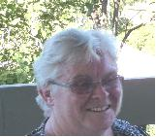
STATUS OF WOMEN – Ros Beveridge
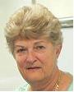Ros has sent out the YWPA applications for this year – cut off date is 22nd September.
UNITED NATIONS – Margaret Finegan
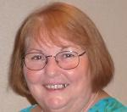This month our guest speaker will be my son Andrew who is home from leave from Tokyo, Japan where he has been teaching English since 1998. He first went to Japan as an exchange student after finishing high school, where he lived in Hakodate on the Island of Hokkaido. He graduated from Queensland Uni as a Bachelor of Arts with a double major in Economics & Japanese. He was then accepted into the graduate training programme with the Australia Taxation Office where he also studied Tax Law. After some years with the ATO he decided he would take a year off and teach English in Japan – his is still there. Andrew will tell us his story of living in Japan since the earthquake and Tsunami earlier this year and about the changes taking place for Japanese women.
I am also once more collecting items for Silky Oaks – boys & girls underwear and socks etc. Please bring any donations to the next meeting.
PR & PROGRAMME
Denise Conroy has been aske

MEMBERSHIP & CLASSIFICATION – Jan Forge
We hope to see our two new ladies attend the August meeting and be inducted.
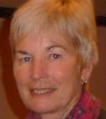
GENERAL NOTES
PI

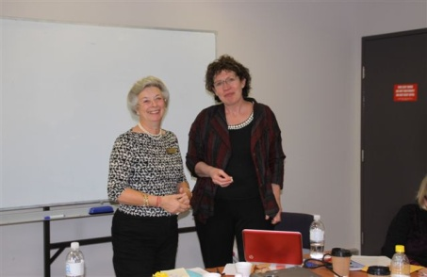  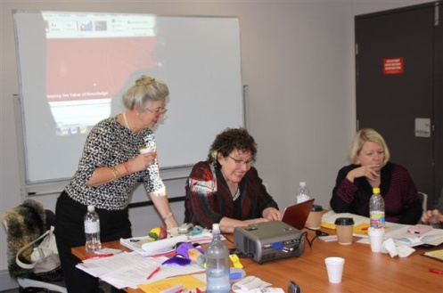 |  | 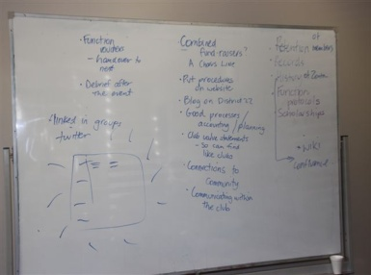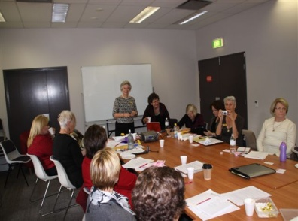
30th Anniversary Celebration: |  | Details to be advised at August meeting.
Next Board Meeting: |  | Monday 22nd August  Venue to be advised.
Girls Knickers (for up to school age)
Pull on slippers or socks for children up to 9 years
Hair accessories
Any school items
All donations will be gratefully received – please bring the items to the August meeting.

