00

ZONTA CLUB OF MOUNT ISA Inc Newsletter

P O BOX 2442, MOUNT ISA QLD 4825

President: Linda Harrison Wk 4743 6733 N/Letter Editor: Kate Larrazabal
Vice President: Michele Savoye Any submissions to N/Letter email to
kalouclarke@bigpond.com
NOVEMBER 2004

President’s Patter

Hello Ladies,

Chrisy is fast approaching. I hope you have all lost that 2 kg you are going to put on over the next two months!

Libby’s Visit
Well, as expected, we made a huge impression on Libby, our Area 7 Director.

She enjoyed herself tremendously, and was very impressed with our fun, frolic and service work (all in the one night too).

LT GOVERNOR AND DISTRICT TREASURER VISIT
We obviously made too good an impression with Libby, as we now have the Lt Governor, Patricia Lawson, and the District Treasurer, Judith Beal visiting us in November.

I did warn them it is our Xmas Night. That only made them more interested in attending. What a great honour. I don’t think we’ve ever had sooo many visits in the one year.

Good to see the District coming out to see us small and out of the way Clubs. Personally, I think the words out that we are “Party Central” for the whole District now. I know we have some fabulous women in the Club. I, for one, can understand their interest.

So ladies, everyone has got to try to come to the November Meeting. Not only to make a good impression (we’d do that anyway!), but so we can tell tales to your husbands/better halves about your antics. Only kidding.

NOVEMBER MEETING
As mentioned above, we will be having our Xmas Meeting next month. All hubbies, In-Laws, boyfriends and girlfriends are welcome.

You would have all received your Invites in the mail by now. Gotta hand it to Shannon, she can organise anything. I reckon if they’d had her on the Titanic, they would have saved everyone!

Don’t forget to RSVP to Margot by Friday, 12th November. (Advise of any guests.)

We are having Games, and Santa is gonna be there and everything!

We will also have Envelopes for you to make a donation, and hang it on the Christmas Tree. All funds raised will go to Serenity House!

ZONTA BREAKY CLUB MELBOURNE CUP BREAKFAST
Four ‘Sleep Deprived’ Members attended the Breaky Club’s Melbourne Cup Meeting. Sadly, we didn’t win the sweep.

We did however have a couple of Champagne and Orange Juices. And you will note in the photos below, that Cherry already looks like she has imbibed too much!

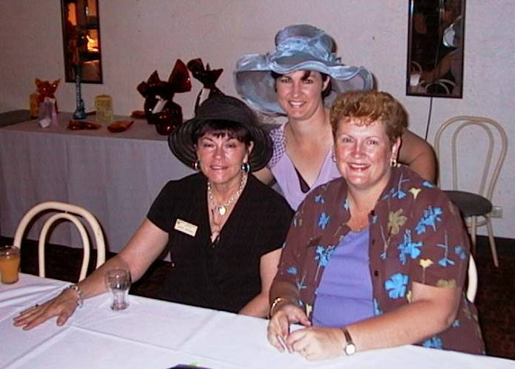

NOTE: HALF ASLEEP CHERRY. Shannon is beautiful as always!

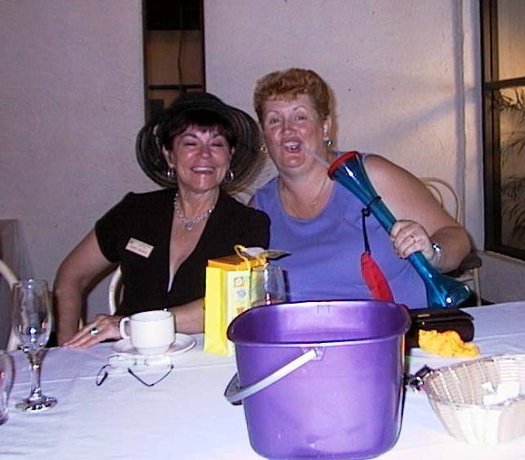

Linda with gift from Breaky Club. (HUGE Bourbon and Coke drink holder!) Will bring it to next meeting to show off! (and hopefully have filled 2 or 3 times). NOTE: Cherry showing cleavage and still looks half sozzled.

I don’t know how Maria (the other Member who attended) stayed out of the photos, I figured it was cause there weren’t any tambourines around! I promise to stop giving you a hard time from now on Maria!

AWARDS NIGHTS AT HIGH SCHOOLS
Michele and I attended an Awards Night for the High Schools each. I attended the Spinifex College Speech Night. Our award winner Selina Taylor is an amazing young lady. We will hopefully have her attending our Xmas Meeting to give us a small talk on herself. (Fingers crossed that we can arrange this)

Anyway, I’ll be brutally frank. I thought I was gonna have to push out ZZZ ‘s whilst most of the night unfolded around moi. Was I wrong, it was great! We have sooo many talented young people in our schools. The number of young girls who won awards! I would say that 85% of awards were taken out by young Girls. Dux of the Senior Class was a young woman. It just goes to show you how remarkable we women are.

I’m sure that Michele enjoyed her night at the Catholic High Speech Night too.

SERVICE AND STATUS OF WOMEN COMMITTEE MEETING
Committee Meeting for S&SOW is at my place on Monday, 8th November 7.30pm.

Discussion on view, and how great the house is, along with IWD, and Birthing Kits.
See all S&SOW Committee Members there!

WINE RAFFLE

WHO HAS FORGOTTEN TO BRING IN THEIR WINE TO THE SHOP!! NAUGHTY ZONTIANS!

How are you going selling tickets? If you need more, Nellie has some at her place.

BIRTHING KITS
As far as I’m aware, Birthing Kit working bee is still on for 5th December.

More info at Meeting.

Date: 5th December, 2004
Time: 10am till we finish
Lunch Provided
If you can’t work all day, try and do a couple of hours. It’s for such a good cause.

CAROLS BY CANDLELIGHT
As mentioned at last meeting, we will be selling Fairy Floss at Carols by Candlelight on December 3rd. We will make it on the night, as it is a better draw.

Hope to have some more info at Xmas Meeting.

That’s all for now! See you at the Xmas Meeting!

ZONTA ON!!
Linda Harrison
El Presidente.

NEWSLETTER SUBMISSIONS

Any submissions for Newsletter, must be in
1st December
(first Wednesday of every month)
email: kalouclarke@bigpond.com

APOLOGIES!
Must be phoned through to

Margot on
4743 5718 Wk

Or 4743 3602 Hm
No later than midday on the Monday before the meeting. Failure to apologise will result in the member paying $22 for meal at the next dinner meeting, or they will receive an invoice for this meal.

OUR BIRTHDAY GIRLS THIS MONTH ARE
Cathy Manners 9th November
Anne Cunningham 21st November
Kate Larrazabal 29th November

*******************************

Thought for the Month
Tell me, I’ll forget.
Show me, I may remember.
But involve me and I’ll understand.

Chinese proverb

Upcoming Events
Fri 12th Nov - RSVP November dinner meeting.

Wed 17th Nov – Xmas dinner meeting.
Terrace Gardens, 7 for 7.15 start. Glass of champagne and musical entertainment on arrival, games, Santa, delicious food…Don’t forget, the theme is Christmas in the Outback 2004.

Fri 3rd Dec – Carols by Candlelight.

Sun 5th Dec – Birthing kits working bee.

Wed 15th Dec – Dinner meeting at Linda’s.

Jan dinner meeting, coffee and cake at Terrace Gardens.

MEMBER QUESTIONAIRE
NAME: Maria Johnstone
WHERE WERE YOU BORN? Cunnamulla, Qld
WHAT’S YOUR FAVOURITE PERFUME? Eternity
WHAT WAS THE LAST MOVIE YOU ENJOYED?
“Radio” I’m a sucker for a “feel-good” movie in which I usually cry, but then love the happy ending.
WHAT DRINK BEST DESCRIBES YOU? I wasn’t sure about this so I asked a friend and she said a “fruit tingle” as it is colourful and fun with many different flavours.
HOW DO YOU FILL IN YOUR SPARE TIME?
Doing whatever Shannon has organised for me to do.
WHAT WAS YOUR MOST EXCITING HOLIDAY?
When my husband and I went to the Melbourne Cup a couple of years ago. (I haven'’ travelled much!!!)
WHAT DO YOU CONSIDER YOUR GREATEST ACHIEVEMENT? My two daughters, Holly and Emma.
WHAT IS YOUR MOST EMBARRASSING MOMENT? Looking like I was the one in the last Zonta newsletter who had no knickers on. For the record, it wasn’t me.

NAME: Shannon Ward
WHERE WERE YOU BORN? Mt Isa
WHAT’S YOUR FAVOURITE PERFUME? Glamorous by Ralph Lauren.
WHAT WAS THE LAST MOVIE YOU ENJOYED?
Sweet Home Alabama.
WHAT DRINK BEST DESCRIBES YOU? Mum tells me champagne because I have a bubbly personality.
HOW DO YOU FILL IN YOUR SPARE TIME?
What spare time?
WHAT WAS YOUR MOST EXCITING HOLIDAY?
Any holiday! Anywhere! Anytime!
WHAT DO YOU CONSIDER YOUR GREATEST ACHIEVEMENT? My family.
WHAT IS YOUR MOST EMBARRASSING MOMENT? Can’t remember – my brain obviously blocks these things out – much like the pain of childbirth.

NAME: Sarah Fraser
WHERE WERE YOU BORN? Toowoomba, Qld
WHAT’S YOUR FAVOURITE PERFUME? Chanel no. 5.
WHAT WAS THE LAST MOVIE YOU ENJOYED?
The Lord of the Rings Trilogy – I want them to make no. 4.
WHAT DRINK BEST DESCRIBES YOU? A dry white wine – can be a quiet one sitting on a deck watching a sunset, but have also been known to party the night away!!
HOW DO YOU FILL IN YOUR SPARE TIME?
With craft – I love making things – sewing, quilting, patchwork and now I’m learning card making.
WHAT WAS YOUR MOST EXCITING HOLIDAY?
Our round the world trip last year (I can’t wait to go again!!)
WHAT DO YOU CONSIDER YOUR GREATEST ACHIEVEMENT? It hasn’t happened yet – watch this space!
WHAT IS YOUR MOST EMBARRASSING MOMENT? Sorry!!! Too many to list! Wait until I have a few too many white wines – I become a great story teller!

“COFFEE CONVERSATIONS”

HIGHLIGHTS OF OUR MEMBERS PERSONAL LIVES
By Liz Ryan

Liz Ryan (Kimoozu)
I love being in Zonta, mostly because of the ladies and the friendships formed, and also knowing when you need help, you only have to ask!

I would like to say a big thank you to, Shelley Slatcher, Dee Wilburn, Tom Fangrath (Linda’s Brother-in-Law) and Linda Harrison for helping out at the St Joseph’s Fete on Friday night. The fairy floss ladies and man worked non-stop for 3 hours to raise funds for St Josephs School.

So once again a big thank you.

Dee is off again to her final Quest, the Spirit of Queensland Awards, and we wish her all the best.

Deanne Wilburn (Our Queen)
This award is held every year for Queenslanders. Anyone can nominate themselves the only requirement is that you raise $5,000 before a certain date to become a finalist. As a finalist they fly you to Brisbane and you get to stay at the Hilton in the City. You have to sit a panel of Judges. This year, the panel includes Jeff Hugell the Australian Swimmer (Butterfly).

I fly out Sunday, 14th November and spend two days at the Brisbane RFDS offices and do some training with their staff. Wednesday we are having drinks and cocktail food in the Atrium Foyer Lounge so we can meet each other and suss out our competition. Thursday is the day of the Judging. And that night we have a Gourmet BBQ to relax after our hard day impressing the judges. Friday we have off to get ready for the Awards Gala Presentation in the Grand Ballroom. This, of course, means I will be wearing my butterfly dress, (as worn by moi when I won the Rodeo Queen). Even if I don’t win, I will be the best dressed or, I’ll have the most unusual dress there.

I hope to do Mount Isa Proud there are five awards all together. I will let everyone know next month how I faired. I am sure that I will have a great time and spend heaps shopping.

I hope everyone has a great night at the Xmas Party, I’m sorry I won’t be able to attend.

Hugs to you all!
Dee (Deanne)
Don’t blame me, I am just passing it on, the punch line on this one is most definitely not expected….
An old lady is very upset as her husband Albert had just passed away.
She went to the undertakers to have one last look at her dearly departed husband.
The instant she saw him she starts crying. One of the undertakers strides up to provide comfort in this sombre moment. Through her tears she explains that she is upset because her dearest Albert was wearing a black suit, and it was his dying wish to be buried in a blue suit.
The undertaker apologises and explains that traditionally, they always put the bodies in a black suit, but he'd see what he could arrange.
The next day she returned to the undertakers to have one last moment with Albert before his funeral the following day. When the undertaker pulls back the curtain, she manages to smile through her tears as Albert is resplendent in a smart blue suit.
She says to the undertaker "Wonderful, wonderful, but where did you get that beautiful blue suit?"
"Well, yesterday afternoon after you left, a man about your husband's size was brought in & he was wearing a blue suit. His wife explained that she was very upset as he had always wanted to be buried in a black suit," the undertaker replied.
The wife smiled at the man.
He continued, "After that, it was simply a matter of swapping the head,

