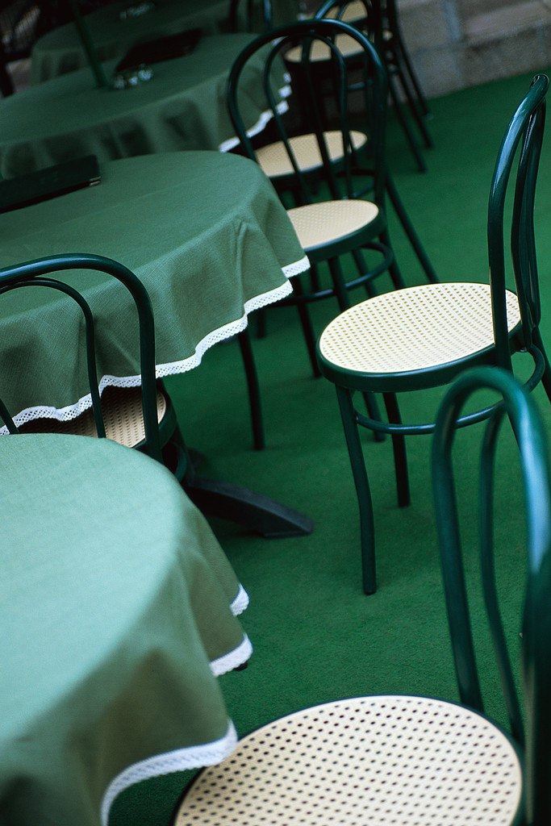
Dinner Meeting:
Contact Alison Ahearn - for all dinner arrangements no later than the Monday prior to our dinner meeting. Advise her of any apologies if you are unable to attend or to let her know of extra dinner guests that you have invited. This will ensure the accurate catering for the Wednesday meeting and appropriate charges for meals.

COST (Includes dinner) Members/Guests $20.00

Special Dietary Requirements:
If anyone has any special dietary requirements will they please inform Alison so that she can inform the club. The club is very happy to cater to individual needs.

Alison Ahearn

Home: 3289 2560
Mobile: 0419 649 278
Email: amy@amyandrews.com.au

Dinner Meeting

PLEASE NOTE:

The next dinner
is back at the
Arana Leagues Club

8th April
Normal cost

Diary Dates:
- 4th April – Sewing Bee – Karen Fuller’s home 9.30am.
- 8th April – Dinner Meeting – Arana Leagues Club 6.30pm

Happy Birthday

….well, we don’t have any members (yet) who have a Birthday in April…so, here are some famous women who were born in April..
Billie Holiday (singer)
Elizabeth Barrett Browning (poet)
Coretta Scott King (civil rights activist/ wife of Martin Luther King)

Bingo Report
PLEASE TAKE NOTE OF CHANGES TO THE ROSTER.

Arrive at 9.05am to set up.

Please allow time to help clean up before we vacate the room. Glasses are to be stacked and put in the dishwasher and the benches wiped down. Tea/coffee etc are stored out the back.

Bingo Roster

April 2nd Tracey
9th Carol
16th Jan & Rosalind
23rd Di Woodland
(not sure if I need another person for this day).
30th Kay

May 7th Tracey & Vicki Bell
14th Bettina
21st Carol
28th Karen
June 4th Jan
Wednesday 11th March
Arana Leagues Club
11th Di Woodland
18th Kay
25th Carol
July 2nd Tracey & Laurie
9th Bettina
July 16th Carole
23rd Karen
30th Vicki Bell
Aug 7th Jan & Di

As usual, I have tried to fit in with everyone’s plans and holidays. I hope this is ok with everyone.
Vicki Williams Bingo Convener

President’s Message

As I'm sure that all that attended the Area Workshop will say it was a great day. The content and the venue were excellent.

Also, the International Women’s Day went well, everyone had an enjoyable day and we await the financial results at the dinner meeting.

I have had a meeting with the leagues club and hope that all the meals are going to be sorted out.

Please do give a thought to our nominations for the board, the board is a great place to be on and you are more in the know about the club and the total Zonta scene.

Lastly we have the breast cushion day on the 4th April so please see if you can find time in your schedule to help for a few hours

Regards,
Jan Spittle

Status of Women Report

At the Area 1 & 3 Meeting a young indigenous university student spoke about how she was helped not only financially by being the recipient of a Zonta Club bursary, but the emotional support, and what it meant to her coming from a disadvantaged background. This year our club needs to discuss the best way to utilize our funds to similarly support a secondary school student.

Single bed sheets and pillows were delivered to Jebb House recently and our Status of Women committee are looking forward to ‘you know who’ returning to Zonta after roaming Australia in a caravan to hopefully continue purchasing the utility kits for Jebb House. Welcome back Vicki Bell and we hope to see you at our coming meetings.

Regards,
Lorraine Hunter



Come & enjoy a day of sewing and good conversation as we produce more breast pillows for delivery to various hospitals around Brisbane.

Karen’s Place
15 Leopardwood Ct Albany Creek
Sat 4th April 9.30 am
Please bring some lunch to share

Organisation, Membership & Classification Committee

Hello members,

COMINGS (good) and GOINGS (bad) …..

How lovely it was to see Vicki Bell at the March meeting. Vicki and her husband have been travelling for some months but now they are back and Vicki is ready to join us again, hurrah! Vicki was (and will return to be) a very active member of the Status of Women Committee snapping up “specials" on kitchen equipment to ensure the Club meets its commitment to supply women in the domestic violence refuge with “new home” starter kits.

The other good news is Jenny Leggo will be returning to Zonta shortly when she and husband Craig move back to Brisbane. Jen doesn’t know where they will be living yet, but she is going to pay her full fees in preparation for re-joining us or another Brisbane Club. I hope it’s us.

The bad news is Elizabeth and Alison have resigned. Both have a lot of family commitments and can only spread themselves so much. We shall miss them both. Elizabeth has had a long and active commitment with the Zonta Club of Pine Rivers, including being Vice President at one stage and Chair of Status of Women Committee for several years. Elizabeth sent Jan and the Club her best wishes and tells me all is well, she is just very busy with an expanding number of grandchildren. Alison too has had a long association with Zonta (first as Z Club president and then much later, Zonta member) and has been our Attendance Officer for the past year. I hope they will both return to us when life allows them the time.

AREA MEETING
The Area meeting on Sunday 22nd March was great, very well organised and with excellent sessions and speakers. We should all be proud of Vicki as both a member of our Club and as our Area Director for all the work she put into it and the results that her efforts achieved.

MEMBER’S PROFILE – Anthea Watson.
Remember we had a very entertaining profile from Alison last month? (good job I nabbed her before she resigned!). Well wait till you read Anthea’s!
Talk about lights under bushels! Anthea has done loads of things I didn’t know about - and on top of that she is producing a fabulous newsletter every month, and she had her head shaved for the Leukaemia Foundation.
Unfortunately we won’t see the immediate results of that as she can’t be with us in April, but I’m looking forward to seeing her spikey head in May.
Meanwhile I know you will enjoy reading Anthea’s profile and finding out a lot more about our brilliant newsletter editor!
See you at the April meeting.

Regards,
Rosalind Pestell

AREA MEETING
22nd March 2009

We had a great turnout for the area meeting with 98 attendees. All in all, everyone enjoyed the day and we all learnt a bit more about Zonta.
I would like to thank the club for supporting me in this area meeting.
This is an excerpt from the Brisbane Club newsletter about the area meeting.
“AREA WORKSHOP STIMULATES AND ENTERTAINS.
The Star turn was unquestionably Katherine Williams, winner of the indigenous bursary at the University of Queensland receiving a standing ovation. Brisbane club members Jen West introduced Katherine, Ann Shevill regaled the room with stories of the Brisbane Club’s early days and Judith Anderson, MC linked the presentations to Area Director Vicki Williams’ theme of “How to succeed in Zonta without really trying”and kept the day running smoothly and on time.
District 22 now has 1221 members in 48 clubs. (13 of which are in Area 1 and Area 1 had representatives from every club in the area – 70 members) as reported by DG Vicki Varthas.
Events to look forward to are: Zonta’s 90th Birthday on Nov. 11 this year: a possible district fundraiser for the Amelia Earhart fund around the October release of the movie Amelia. Starring Richard Gere and Hilary Swank.”

I would like to thank Simone for all the photocopying and time she put in to help me with the program, bookmarks etc.
I would like to thank Suzanne for keeping the books in order and we made a small profit that needs to go back to the OMC for the district board.

Regards,
Vicki Williams
Area Director
Member Profile

Anthea Watson

I grew up in a small suburb of Sydney called Denistone. I was spoilt in this respect because it was a lovely, leafy suburb that was only 2 mins walk to the train or bus, had not too many shops, great bike paths and a hospital just up the road. The only down side was the numerous steep hills (we lived halfway up one) which meant jogging always started with going DOWN the street, and missing the bus to school meant walking 5 kms and started with walking UP the hill. However, the view over the city from the top of the street made up for it.

And I lived with my mum and dad, my older brother, our 2 cats and various grandmothers as the need arose.

My biggest move (home –wise) to date was when I got married and moved to Brisbane in 1991. However, this was not before an extended “honeymoon” where we both quit our current jobs and bushwhacked around Australia for 5 months. Of course, this was in an inefficient petrol Landcruiser (which we slept in the back of) driving hundreds of kilometres just as the Gulf War broke out and petrol prices skyrocketed to $1/L in most outback centres (which was a lot 18yrs ago)! Needless to say, this blew the budget and so fruit-picking jobs ensued along the way to help get us around. But I have to say, Australia is one of the most beautiful places I have ever seen and we were thankful to have explored it and its people before we went backpacking overseas years later.

People/pets and possessions dearest to me now: are my husband, our two greyhounds, our two lovely chickens, as well as the beautiful piece of bush that we “caretake” here at Kobble Creek.

My business or profession is: I think “eternal student” would just about cover it. I began by completing an honours degree in classical Archaeology (Greek, Egyptian, Palestinian etc) at Sydney University whereupon our final season’s dig in Jordan was promptly cancelled due to the not unexpected risk of being hit by a stray bullet as the Middle East conflicts began to flair up. At which point I got a better offer from my now husband to get married, jaunt around Australia and then come live with him in Brisbane. Of course, there aren’t too many ancient classical sites or pyramids to be found here, so I did a short stint at the Brisbane museum in the aboriginal archives department instead. In the mean-time my husband’s repair business was taking off and my intake of piano students was steadily growing (I had been studying piano externally since I was eight). So, I decided it was time to leave archaeology where it belonged - in the past - and get on with the business of making ends meet. I did the office work for the business and taught piano after hours. Whilst doing this I also did a travel consultant’s course, started a social work degree and worked odd hours selling sewing machines at Myers.

My current work or main occupation is - still the office work and the music teaching. And, although I love the contact with students and watching them grow as musicians and people, I had the recent urge to move out of my comfort zone (20 years of teaching is toooo comfortable) and so am halfway through a degree in Traditional Chinese medicine (acupuncture, herbs etc) in the hope that I may be able to guide/help people in a new way.

My other interests and/or skills and/or indulgences include: learning the cello, stargazing, gardening, volunteering with animal protection associations and working with people with disabilities.
Month & year joined Zonta: May 2008.

I joined Zonta because: I kept reading the articles in the Village Pump about what Zonta was doing. And because Vicki was so enthusiastic when I rang up to enquire.

I remain in Zonta because: of the great work they do. And because, maybe by mixing with some of the most knowledgeable and committed women I have ever met some of the magic might rub off and I can learn to contribute in a meaningful way as well.

Positions held in Zonta: UN committee, newsletter editor.

Positions I’d be willing to try sometime: only time will tell….

Extra Diary Dates…..
AREA
WORKSHOP
21st March 2010
Maroochy and Blackall clubs are going to be the hosts.

DISTRICT CONFERENCE
25TH – 27TH September 2009
at Rydges Southbank, Townsville
Keep an eye open for good air prices!!

International Convention 2010
San Antonio, USA

International convention 2012 Italy

Courtesy of our Area Director,
Vicki.

